**Vue js component**

1. What is vue js?

* Vue is a progressive framework for building user interfaces. Unlike other monolithic frameworks, Vue is designed from the ground up to be incrementally adoptable. The core library is focused on the view layer only, and is easy to pick up and integrate with other libraries or existing projects. On the other hand, Vue is also perfectly capable of powering sophisticated Single-Page Applications.

1. Why is Vue js components?

* Vue js component is a javasrcipt framework use to develop SPA (single page applications).
* Components are reusable Vue instances with custom HTML elements and we can be reused as many times or another component like a child component.
* Data, computed, watch, and methods can be used in a Vue component

1. What I did today:

* I did on my project (Student life):
  + In the morning: design Card list, create, delete and edit.
  + 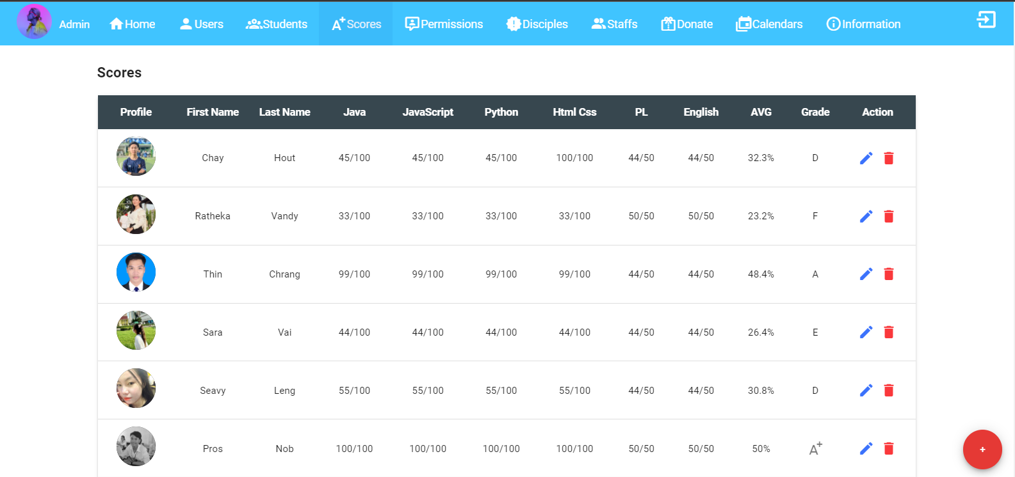In the afternoon: manage on students score.
* Design card for profile user

